Writing a Compare and Contrast Essay
Learning Objective:
- Write a multi-paragraph compare and contrast essay.
- Minimum 5-7 paragraphs and 35 sentences
LESSON
In this lesson, you will learn how to write a compare and contrast essay, which is among the most common writing assignments in college classes. This structure is used to show how things are alike (compare) and different (contrast). For example, you might be asked to compare and contrast two characters in a novel. In such an essay, you would do more than just tell what each character is like or does. A good compare and contrast essay goes beyond simple description or summary to draw connections between the characters and really analyze them. It is important to note that compare and contrast essays do not necessarily require you to include both similarities and differences. Sometimes the focus will be on either comparing or contrasting, depending on the subjects being compared.
In this lesson, you will learn eight steps to develop a compare and contrast essay:
- Understand your assignment.
- Gather ideas.
- Create a working thesis.
- Develop an outline.
- Develop paragraphs that support your thesis.
- Write a conclusion.
- Write an introduction.
- Revise your essay.
Step 1: Understand your assignment.
Read the guideline sheet or rubric. Do you get to choose what to compare, or has your instructor given you a specific topic? You need to look for keywords like similarities, differences, alike, two, parallels, and disparities to make sure that you need to write a compare and contrast essay. In some cases, your instructor may only ask you to compare or contrast. Make sure you understand what your instructor is asking for before you begin.
Step 2: Gather ideas.
If your instructor assigns you a specific subject to write about, then the next step in the process is to gather ideas. If you must come up with your own subject, there are a few things you should consider before you start to brainstorm ideas.
First, make sure that your subject is of appropriate scope for the assignment, not too broad and not too narrow. Comparing President Ronald Reagan to President Jimmy Carter, for example, is too broad for a five-page essay. But comparing their foreign policies may not be, depending on how detailed the comparison is supposed to be.
Once you are sure your subject is of the appropriate scope, be sure to carefully consider whether the two things you are writing about are a good match to the compare and contrast format. Do they have important similarities and/or differences? Will comparing them help to clarify something or lead to new insights about a subject?
If you are unsure about these questions, then gathering ideas will probably help you to decide. There are many good ways to gather ideas for essays. For compare and contrast essays, a Venn diagram is a particularly useful tool. The overlapping part of the circles shows similarities; the outer circles show differences or unique qualities. Here is a very simple example of a Venn diagram.
Comparison of the benefits of dogs and cats as pets
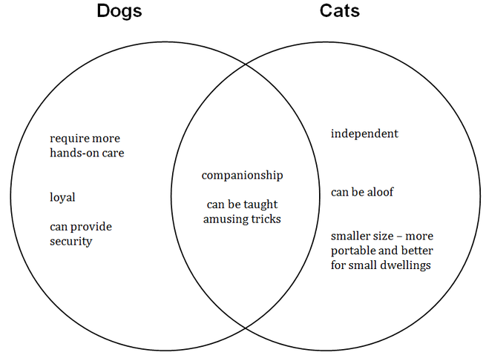
You could also make a chart that lists different qualities of each, or simply group information by how they are alike or different.
Remember, it is critical that there are points of overlap, or similarities, as well as differences between your topics. Without both aspects, it will be difficult to write an analysis that will make your essay meaningful.
Step 3: Create a working thesis.
Regardless of the kind of essay you are writing, there are certain qualities of a good thesis: it must be specific, clearly state your main idea, and demonstrate for the reader why the subject is important. For a compare and contrast essay, you will also need to decide whether to write an evaluative or an explanatory thesis.
An evaluative thesis reflects an opinion or judgment about the two things being compared.
Example evaluative thesis:
Although wind turbines and solar panels both create less greenhouse gasses than fossil fuels, solar panels are much more environmentally friendly.
An explanatory thesis compares two subjects without taking a stance.
Example explanatory thesis:
While both wind turbines and solar panels have their own shortcomings, both offer a number advantages over traditional energy sources.
Remember, your thesis will drive the development of your essay. It will help you sort through all the possible points of comparison to arrive at the most important ones.
Step 4: Develop an outline.
Next, you will develop an outline for your essay. The two most common methods for compare and contrast essays are the point-by-pointmethod and the subject-by-subject method.
In the point-by-point method, the writer outlines the major points of comparison between the two subjects, and then addresses both subjects for each major point. In the subject-by-subject method, the writer first discusses important aspects of one of the subjects, then those same aspects for the other subject. These points must be parallel, meaning that all aspects addressed with one subject need to also be addressed with the other subject in the same order. This is also known as the block method.
Point-by-point outline  - Introductory Paragraph  - Hook  - Tone  - Background  - Thesis  - Body Paragraphs  - Point of comparison 1  - Subject A  - Subject B  - Point of comparison 2  - Subject A  - Subject B  - Point of comparison 3  - Subject A  - Subject B  - Concluding Paragraph | Subject-by-subject outline  - Introductory Paragraph  - Hook  - Tone  - Background  - Thesis  - Body Paragraphs  - Subject A  - Point of comparison 1  - Point of comparison 2  - Point of comparison 3  - Subject B  - Point of comparison 1  - Point of comparison 2  - Point of comparison 3  - Concluding Paragraph
The format to follow is really up to you. Writers often find that the point-by-point essay makes the connections between the points of comparison clearer and easier for the reader to understand. It is better for longer essays with more complicated ideas. Your points of comparison should generally be organized from most to least important (though all of them should be important!) so that you can hook your reader with your most compelling ideas first. A subject-by-subject outline might be better if you are writing an explanatory, rather than an evaluative, essay. It is often used for shorter essays. Whichever you choose, make sure that you are consistent with the format throughout your essay.
Step 5: Develop paragraphs that support your thesis.
The paragraphs in the body of your essay must support your thesis as it is stated in the introduction. In addition, they should adhere to the MEAL concept:
Main Idea: your topic sentence, comprising either one of the subjects (for subject-by-subject comparison) or one of the points of comparison (for a point-by-point comparison)
Evidence: points of comparison (for subject-by-subject comparison) or the subjects (for a point-by-point comparison)
Analysis: explaining how the comparison is valid and/or unexpected
Link: a transition from the paragraph, as well as back to the thesis
There may be more than one piece of evidence or point of analysis in a paragraph, but every paragraph should have all four of these elements.
Step 6: Write a conclusion.
The conclusion of your essay must synthesize, or bring together, the critical details of your essay. It should try to give the reader a new way of looking at your main idea. It reminds the reader of your thesis and reinforces the main points you have made.
Step 7: Write an introduction.
There are four elements of an effective introduction:
- Hook
- Tone
- Background
- Thesis
An effective introduction hooks the reader with a compelling idea, sets the tone for the rest of the essay, provides any necessary background or context for the reader, and presents the thesis.
Step 8: Revise your essay.
When you have a draft of your essay, ask yourself these questions:
- Have I followed the assignment?
- Is this a compare and contrast essay? What subjects am I comparing? What are my points of comparison?
- Do my body paragraphs support my thesis?
- Is all of my support relevant?
- Do I need more or less support?
- Have I included the transitions necessary to guide the reader from point to point?
- Does my conclusion synthesize the critical details?
- Does my introduction hook the reader and provide adequate background/introduction to my topic?
Review your entire essay with these questions in mind. Remember, you may need to add information, remove information, or reorganize your writing. Being a careful reviewer of your own work is key to a quality essay. When you have completed this step, be sure to go back one more time to verify that your grammar, spelling, and punctuation are correct.

- PRACTICAL APPLICATION
Being able to effectively compare and contrast subjects is important in both school and your career. It can even be important for you when making decisions outside of school and career.
Comparing and contrasting subjects is an excellent structure for making connections between ideas and engaging in critical thinking. For example, in your career, you might be asked to evaluate the merits of two different computer operating systems and make a recommendation. The stronger your points of comparison, the better the analysis you can present, and the better the impression you will make.
Being able to write strong compare and contrast essays will also allow you to recognize when others compare subjects effectively—and when they do not. It will help you to recognize logical errors and misleading comparisons and improve your own critical analysis skills.
- EXAMPLE
The example below shows the subject-by-subject approach to writing a compare and contrast essay.
Step 1: Understand your assignment.
The assignment is to write a four- to six-paragraph essay comparing two breeds of dogs of your own choosing.
Step 2: Gather ideas.
In this example, the writer has used a Venn diagram to gather and organize ideas.
Comparison of German Shepherds and Golden Retrievers
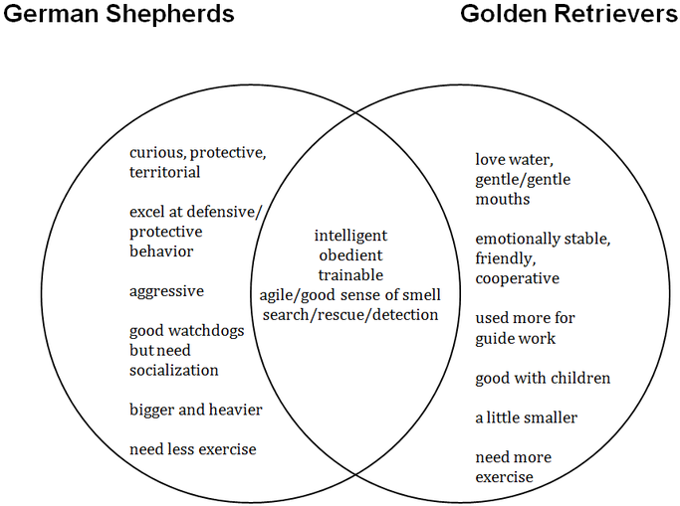
Step 3: Create a working thesis.
Here is a possible thesis based on the ideas gathered:
German shepherds' and golden retrievers' unique qualities make them suitable for different families and work roles.
Step 4: Develop an outline.
- Introductory Paragraph
  - Hook: If you are looking for a large, intelligent dog to provide service or companionship, many breeds could fit the bill.
  - Tone: Informal
  - Background: German shepherds and golden retrievers are both popular dog breeds, in part, for their intelligence and ability to serve and keep company.
  - Thesis: Their unique qualities make them suitable for different families and work roles.
- Body Paragraphs
  - Subject A: German Shepherds
    - Point of comparison 1: Temperament
      - Intelligent
      - Fast
      - Keen sense of smell
      - Loyal
      - Aggressive, fearless
      - Active
      - Curious
      - Over-protective if not socialized properly
      - Territorial
      - Do not care for strangers
      - Defensive
      - Work without being distracted
    - Point of comparison 2: Physical characteristics
      - Fast
      - Strong
      - Keen sense of smell
      - Generally, tan with black back and snout; also black, white, sable, liver, and blue varieties
      - Range from 50 to 90 pounds and 22 to 26 inches in height
      - Need thirty minutes of exercise a day
    - Point of comparison 3: Care
      - Do not need ears cleaned often because they are not prone to ear infections
      - Need regular bathing and brushing
  - Subject B: Golden Retrievers
    - Point of comparison 1: Temperament
      - Intelligent
      - Loyal
      - Friendly
      - Kind
      - Calm
      - Eager to please
      - Patient
      - Naturally sociable
      - Willing to learn
      - Patient with children
      - Poor guard dogs
      - Not aggressive to people or other animals
    - Point of comparison 2: Physical characteristics
      - Athletic
      - Agile
      - Good swimmers
      - Range from gold to cream in color
      - Range from 60 to 75 pounds and 21 to 24 inches in height
      - Need two or more hours of exercise a day
    - Point of comparison 3: Care
      - Ears must be cleaned since they are prone to infection
      - Need grooming once a week
- Concluding Paragraph
  - Synthesis
  - Final impression
Step 5: Develop paragraphs that support your thesis.
The thesis indicates that the writer is going to present parallel facts about the two dog breeds, rather than render a judgment about them. With this in mind, the next step is to develop supporting paragraphs, making sure to maintain the subject-by-subject structure throughout.
German shepherds are very curious, loyal dogs. Surprisingly, for an active breed that tends to be bigger than most retrievers, German shepherds only need about thirty minutes of exercise a day; one walk and a few rounds of fetch in the yard should be enough. Additionally, with a double coat, they do require regular brushing; however, unlike many breeds, their ears do not need to be cleaned frequently because German shepherds are not prone to ear infections. A family looking for a dog who will be both protective and not require too much care might enjoy a German shepherd.
A family that is looking for a friendly dog who gets along with everyone should take a look at a golden retriever. Golden retrievers are calm, patient, and eager to please. They can tolerate small children crawling all over them. But golden retrievers are not for people who want a dog to guard their families because golden retrievers are too good-natured to be wary of strangers. Golden retrievers are a bit smaller on average than German shepherds, but they require much more exercise. Golden retrievers require more care than other breeds because their hair tends to mat and knot. However, this care will be worth it for a family that is looking for an active, playful pet to love.
Step 6: Write a conclusion.
After the body paragraphs have been written, it is time to write the conclusion. Remember that the conclusion should synthesize critical details and remind the reader of the thesis without repeating it.
German shepherds and golden retrievers have some similarities and some differences. Traditionally developed for hunting and herding, they still perform those skills beautifully while expanding into new fields.
Step 7: Write an introduction.
The next step is to write the introduction. Remember the four elements of an effective introduction: hook, tone, background, and thesis.
If you are looking for a large, intelligent, active dog to provide service or companionship, many breeds could fit the bill. Of these, the German shepherd and the golden retriever are among the most popular, yet they have many differences. Their unique abilities make them suitable for different families and work roles. The dog that you choose should be tailored to your personal situation and wishes.
Step 8: Revise your essay.
Finally, review, revise, and proofread the essay, using the eight questions outlined in the lesson. Read the revised essay below, along with the list of revisions that show how it was improved.
According to the American Kennel Club, golden retrievers and German shepherds have both been among the top three most popular dog breeds in the United States. Their popularity stems, in part, from their intelligence and ability to serve and keep company. Despite sharing these characteristics, German shepherds and golden retrievers are very different breeds, and potential owners must understand these differences to ensure they choose the breed that is best suited to their homes.
German shepherds are very curious, loyal dogs. If not socialized properly, their loyalty can turn into over-protectiveness. Combined with their aggressive and defensive nature, German shepherds may not be the best choice for families introducing new children into the mix. They are, however, excellent guard dogs and will alert their owners to any strangers on their properties. Surprisingly, for an active breed that tends to be bigger than most retrievers, German shepherds only need about thirty minutes of exercise a day; one walk and a few rounds of fetch in the yard should be enough. Additionally, with a double coat, they do require regular brushing; however, unlike many breeds, their ears do not need to be cleaned frequently because German shepherds are not prone to ear infections. A family looking for a dog who will be both protective and not require too much care might enjoy a German shepherd.
On the other hand, a family that is looking for a friendly dog who gets along with everyone should take a look at a golden retriever. Golden retrievers are calm, patient, and eager to please. They can tolerate small children crawling all over them. But golden retrievers are not for people who want a dog to guard their families, because golden retrievers are too good-natured to be wary of strangers. Golden retrievers are a bit smaller on average than German shepherds, but they require much more exercise—two or more hours a day. Golden retrievers require more care than other breeds because their hair tends to mat and knot. Additionally, since they are prone to ear infections, their ears must be regularly cleaned. However, this care will be worth it for a family that is looking for an active, playful pet to love.
German shepherds and golden retrievers fulfill some of the most critical roles we have for working dogs, and they make wonderful companion animals. Traditionally developed for hunting and herding, they still perform those skills beautifully while expanding into new fields. They are as important to us as ever and are loved in our homes today.
Here is a list of revisions to this essay.
Introductory Paragraph:
- Added an interesting fact for a stronger hook.
- Revised the last sentence to clearly introduce differences in subjects.
Body Paragraph A:
- Revised to ensure the points of comparison are parallel. The golden retriever paragraph discusses temperament, so some lines were added to outline the temperament of German shepherds.
Body Paragraph B:
- Added a transition, On the other hand, to signal that a contrast is being made between the two breeds.
Concluding Paragraph:
- Rewrote the first sentence; it was weak and did not add anything to the essay. The new sentence summarizes the essay more strongly.
- Added a closing sentence with a warm, personal comment to pull in the reader.
- YOUR TURN
Follow the eight steps to write a compare and contrast essay on the benefits of walking versus running for exercise. You may use either the point-by-point or the subject-by-subject format.
Step 1: Understand your assignment.
–
Sample Answer

The assignment is to write a compare and contrast essay on the benefits of walking versus running for exercise, using either the point-by-point or subject-by-subject format. I choose to use the point-by-point format.
Step 2: Gather ideas.
–
Sample Answer

Comparison of Walking and Running for Exercise
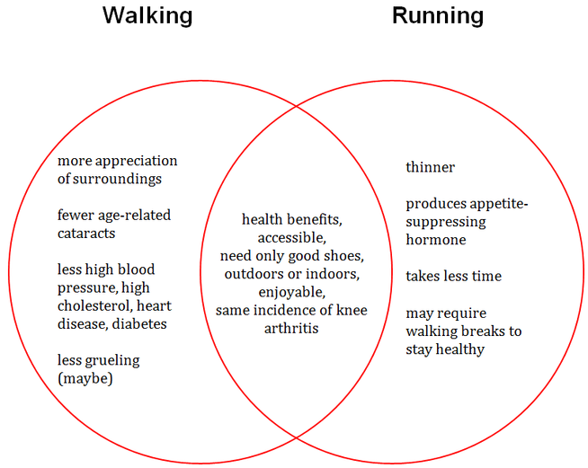

Step 3: Create a working thesis.
–
Sample Answer

While either walking or running can be a great way to get in shape, each has distinct benefits that could make it a better choice for you.
Step 4: Develop an outline.
–
Sample Answer

Walking and Running for Exercise
- Introductory Paragraph
  - Hook: Exercise, it has been said, is not an option.
  - Tone: Informal
  - Background
    - To increase health, commit to a regular workout routine.
    - Of all activities, walking and running are among the most accessible and effective.
  - Thesis: While either activity can be a great way to get in shape, each has distinct benefits that could make it a better choice for you.
- Body Paragraphs
  - Point of comparison 1: Time commitment
    - Subject A: Walking: At least twice as long as running.
    - Subject B: Running: Tends to be half as long as walking.
  - Point of comparison 2: Health benefits
    - Subject A: Walking
      - Lower incidence of age-related cataracts.
      - Lower incidence of high blood pressure, high cholesterol, heart disease and diabetes.
    - Subject B: Running
      - Runners are thinner than walkers.
      - Produces an appetite-suppressing hormone.
  - Point of comparison 3: Effort
    - Subject A: Walking: Walking faster lengthens life.
    - Subject B: Running: Walking breaks reduce injury.
- Concluding Paragraph
  - Synthesis
  - Final impression
Step 5: Develop paragraphs that support your thesis.
–
Sample Answer

Running and walking require different levels of time commitment. It is entirely possible to burn as many calories walking as it is running, but it will take much longer. The exact numbers depend upon how fast you run versus how fast you walk, but a good rule of thumb is that it takes twice as long to walk off the same number of calories as it does to run them off.
While both activities burn calories, their other benefits are quite different. Interestingly, studies show that runners are thinner than walkers even when the two groups expend the same amount of energy. Researchers believe that running produces an appetite-suppressing hormone that walking does not. However, if you are looking to do more than lose weight, you may want to stick to walking. Walkers had a lower incidence of age-related cataracts when compared to both runners and the general population. Walkers also had lower incidences of high blood pressure, high cholesterol, heart disease, and diabetes.
You should look at how much effort each requires. While it seems different than what you might expect, to stay healthy, runners actually need to slow down from time to time as they run. On the other hand, walkers would greatly benefit from picking up the pace a bit. It seems that a combination of the two exercises might offer more benefits than just one or the other. Hopefully future studies will delve into that very question.
Step 6: Write a conclusion.
–
Sample Answer

Both running and walking can be excellent choices for you to increase your life expectancy and your overall lifestyle. As with any exercise routine, be sure to check with your doctor before beginning any new fitness regimen.
Step 7: Write an introduction.
–
Sample Answer

To increase your overall health and well-being, you should commit to a regular workout routine. Of all the activities available to keep you in shape, running and walking are among the best. While either activity can be a great way to get in shape, each has distinct benefits that could make it a better choice for you.
Step 8: Revise your essay.
–
Sample Answer

Today's athletes might be surprised that the earliest runners did so while nude. As uncomfortable as that sounds, running is a great way to keep healthy, clothes or no clothes. Recent studies show that walking also offers similar benefits. Both are a great way to get in shape; however, you should understand the unique features of each before you choose between a running and a walking regimen.
Running and walking require different levels of time commitment. It is entirely possible to burn as many calories walking as it is running, but it will take much longer. The exact numbers depend upon how fast you run versus how fast you walk, but a good rule to remember is that it takes twice as long to walk off the same number of calories as it does to run them off. If you have a limited amount of time and want to burn as many calories as you can, running might be a better option; however, you may not be able to run very long, and in that case, walking, or a combination of the two could be the best choice.
While both activities burn calories, their other benefits are quite different. Interestingly, studies show that runners are thinner than walkers, even when the two groups expend the same amount of energy. Researchers believe that running produces an appetite-suppressing hormone that walking does not. However, if you are looking to do more than lose weight, you may want to stick to walking. Walkers had a lower incidence of age-related cataracts when compared to both runners and the general population. Walkers also had lower incidences of high blood pressure, high cholesterol, heart disease, and diabetes. Which activity is best for you depends upon your health goals.
The last consideration you should make before choosing between a walking or running plan is the effort each requires. While it seems different than what you might expect, to stay healthy, runners actually need to slow down from time to time as they run. Walking breaks reduce injury. On the other hand, walkers would greatly benefit from picking up the pace a bit. This has been shown to lengthen walkers' lives. It seems that a combination of the two exercises might offer more benefits than just one or the other. Hopefully future studies will delve into that very question.
According to a 2012 study in PLOS Medicine, people will gain seven more minutes of life for every six minutes that they exercise, and both running and walking can be excellent choices for you to increase your life-expectancy and your overall lifestyle. As with any exercise routine, be sure to check with your doctor before beginning any new fitness regimen.
Now, list the revisions you made to your essay by section.
–
Sample Answer

Introductory Paragraph:
- Added a surprising fact for a new, more compelling hook.
- Added a transition to smoothly link the hook to the thesis.
- Strengthened the thesis statement.
Body Paragraph A:
- Added analysis at the end of the paragraph to explain the earlier pieces of evidence.
Body Paragraph B:
- Added a link to the next paragraph.
Body Paragraph C:
- Reworded the first sentence to make a better transition from paragraph two and also to reinforce the link to the thesis.
Concluding Paragraph:
- Added evidence to support the thesis and drive the point home.
- METACOGNITIVE QUESTION
How will you know when you need to write a compare and contrast essay?
–
Sample Answer

You need to write a compare and contrast essay when you need to analyze similarities and differences between two subjects and draw some conclusions about them.

