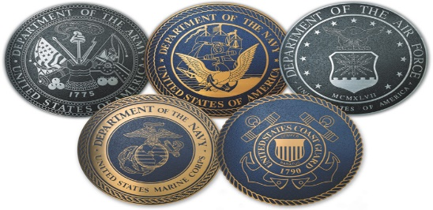

Military Recruiters
U.S. Army
Staff Sergeant Matthew Lynd
US Army Recruiting Station
4205 W Anthem Way, Ste 103
Anthem, AZ 85086
Email: mathew.lynd@usarec.army.mil
Office: (623) 465-3249
Cell: (877) 764-2395
Fax: (623) 465-2611
National Guard
SSG Timothy Ouellette
Recruiter/Career Counselor
3230 E Union Hills Dr
Phoenix, AZ 85050
Email: timothy.l.ouellette.mil@mail.mil
Cell: (602) 885-7514
Fax: (623) 321-1888
U.S. Air Force
SSgt Bradley Hanzawa
Staff Sergeant, USAF
1915 W Union Hills Dr.
Phoenix, AZ 85027
Email: bradley.hanzawa@usaf.mil
Office: (602)938-2023
Toll Free: 1-800-423-USAF
Fax: (602) 548-9437
U.S. Marine Corps
Thomas Brown
Sergeant, USMC
Marine Corps Recruiting Station
1915 West Union Hills Dr.
Phoenix, AZ 85027
Email: thomas.brown@marines.usmc.mil
Office: (602)843-1855
Cell: (602)524-9199
Fax: (602)843-2856

U.S. Marine Corps
Jeff Arroyo
Captain, USMC
Marine Corps Recruiting Station
1 North Street, Suite 302
Phoenix, AZ 85004
Email: jeffrey.arroyo@marines.usmc.mil
Office: (602) 307-5570
Cell: (602) 326-4833
Fax: (602) 252-9303
U.S. Navy
Michael Johnson
NRS Bell Canyon
1923 West Union Hills
Phoenix, AZ 85027
Email: michael.p.johnson52@navy.mil
Cell: (602) 339-2265
Fax: (602) 978-9360
Military Career Guide
United States Air Force Academy
United States Naval Academy
United States Merchant Marine Academy
United States Military Academy West Point
United States Coast Guard Academy

