Engine Oil & Filter Change
Print
All late model trucks are designed to run on unleaded gasoline. Any vehicle originally equipped with a catalytic converter MUST use unleaded gasoline.

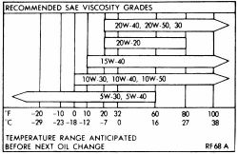

Fig. Gasoline engine oil viscosity chart
The recommended oil viscosities for sustained temperatures ranging from below -10ºF (-23ºC) to above 100ºF (38ºC) are listed in this section. They are broken down into multi-viscosities and single viscosities. Multi-viscosity oils are recommended because of their wider range of acceptable temperatures and driving conditions.
When adding oil to the crankcase or when changing the oil and filter, it is important that oil of an equal quality to original equipment be used in your truck. The use of inferior oils may void the warranty, damage your engine, or both.
The Society of Automotive Engineers (SAE) grade number indicates the oil's viscosity (its ability to lubricate at a given temperature). The lower the SAE number, the lighter the oil; the lower the viscosity, the easier it is to crank the engine in cold weather but the less the oil will lubricate and protect the engine in high temperatures. This number is marked on every oil container.
Oil viscosities should be chosen from those oils recommended for the lowest anticipated temperatures during the oil change interval. Due to the need for an oil that embodies both good lubrication at high temperatures and easy cranking in cold weather, multigrade oils have been developed. Basically, multigrade oil is thinner at low temperatures and thicker at high temperatures. For example, a 10W-40 oil exhibits the characteristics of a 10 weight (SAE 10) oil when the truck is first started and the oil is cold. Its lighter weight allows it to travel to the lubricating surfaces quicker and offer less resistance to starter motor cranking than, say, a straight 30 weight (SAE 30) oil. But after the engine reaches operating temperature, the 10W-40 oil has about the same viscosity that straight 40 weight (SAE 40) oil would have at that temperature.
The American Petroleum Institute (API) designations, also found on the oil container, indicate the classification of engine oil used under certain given operating conditions. Only oils designated for use Service SJ (or a later superceding designation) heavy-duty detergent should be used in your truck. Oils of the SJ type perform may functions inside the engine besides their basic lubrication. Through a balanced system of metallic detergents and polymeric dispersants, the oil prevents high and low temperature deposits, while keeping sludge and dirt particles in suspension. The oil neutralizes acids, particularly sulfuric acid, as well as other by products of engine combustion. If these acids are allowed to concentrate, they can cause corrosion and rapid wear of the internal engine parts.

WARNING
Non-detergent motor oils or straight mineral oils should NOT be used in your gasoline engine.

Oil & Filter Change

NOTE
You will need a container which is capable of holding a minimum of 7 quarts of oil for gasoline engines or 11 quarts for the diesel. (Check the "Capacities" chart for your engine.) A container larger than the oil capacity is recommended so that it can be easily slid out from underneath the truck without the danger of spillage.

CAUTION
The EPA warns that prolonged contact with used engine oil may cause a number of skin disorders, including cancer! You should make every effort to minimize your exposure to used engine oil. Protective gloves should be worn when changing the oil. Wash your hands and any other exposed skin areas as soon as possible after exposure to used engine oil. Soap and water, or waterless hand cleaner should be used.

The oil should be changed more frequently if the vehicle is being operated in very dusty areas. Before draining the oil, make sure that the engine is at operating temperature. Hot oil will hold more impurities in suspension and will flow better, allowing the removal of more oil and dirt.

NOTE
Though some manufacturers have at times recommended replacement of the filter at every other oil change, Chilton recommends the filter be replaced with each engine oil service. The small amount saved by reusing an oil filter rarely justifies the risk. A clogged or dirty filter may fail to protect the expensive internal parts of your engine.

- Loosen the drain plug with a wrench.
- Unscrew the plug using a rag to shield your fingers from the heat. Push in on the plug as you unscrew it (this should prevent oil from escaping past the threads until the plug is removed).
- Once the plug is unthreaded, quickly pull it and your arm back, away from the hot oil. Watch the oil drain and, if necessary, move the pan to keep it underneath the stream of oil. Be careful of the oil. If it is at operating temperatures, it is hot enough to burn you.

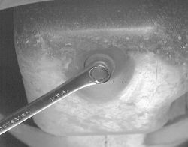

Fig. Loosen the oil drain plug with a wrench, and then carefully remove it with your fingers
- Give the oil sufficient time to drain in order to assure you have removed the most oil and dirt possible, then carefully install the drain plug. Make sure the plug is properly tightened, but do NOT overtighten the plug, as the threads are easily stripped.

WARNING
Do NOT reuse self-tapping drain bolts!

- Change the filter as described below.
- Add the correct quantity of oil, ensuring the correct grade and viscosity.
- Start and run the engine for a few minutes. The oil pressure light may stay on for a few seconds while the filter fills up. Shut off the engine and let the oil settle for a few minutes. Check level and top up if necessary. The vehicle should be on a level surface for an accurate dipstick reading.
- Check for leaks. Be sure to check the drain plug for looseness or seepage after the engine has been fully warmed.

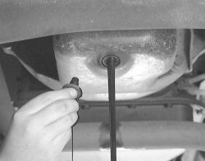
Fig. Unscrew the bolt the rest of the way-be cautious with the stream of heated oil that will follow

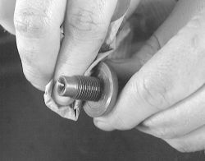
Fig. Be sure to clean and inspect the drain plug threads. Do NOT reuse self-tapping bolts

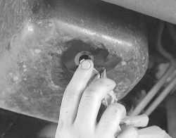
Fig. Clean the area around the drain hole
Oil Filter Change
Screw-On Oil Filter
To remove the filter you will need a quality oil filter wrench. The filter may be fitted tightly and the heat from the engine may make it even tighter. A filter wrench can be obtained at an auto parts store and is well worth the investment, since it will save you a lot of grief. Two types of filter wrenches are available: the strap wrench and the cup type wrench. The one that is best for you may depend on filter location and accessibility. Also note that strap wrenches may not work on smaller oil filters, while some cup wrenches are often designed specifically to fit only the filters made by a single manufacturer.

NOTE
Oil filter wrenches are available in different size ranges. Be sure to select a wrench of the proper circumference.

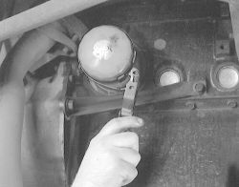
Fig. Spin-on oil filters are easily removed using a filter wrench. For installation, most filters should be tightened 3/4 to 1 turn after contact. Proper torque is on the filter body

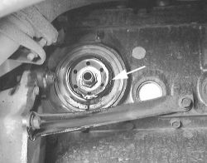
Fig. When the filter is removed, make sure the gasket does not stick to the mounting boss, as in this photo

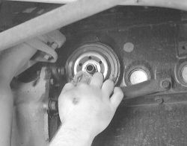

Fig. Be sure to clean the mounting boss' gasket surface before installing the new filter
- Drain the crankcase oil as outlined above.
- Position a drain pan under the filter before you start to remove it from the engine; should some of the hot oil happen to get on you, you will have a place to dump the filter in a hurry.
- Loosen the filter with the filter wrench. With a rag wrapped around the filter, unscrew the filter from the boss on the side of the engine. Be careful of hot oil that will run down the side of the filter.
- Wipe the base of the mounting boss with a clean, dry cloth.

NOTE
Make sure the old filter gasket was removed with the filter and is not left on the engine adapter. If the old gasket is left in place, you are almost assured to have an oil leak.

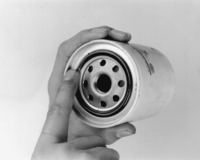
Fig. Coat the gasket on the new filter with fresh engine oil. Partially filling the new filter with oil will reduce the time the engine must run dry on start up
- When you install the new filter, smear a small amount of new engine oil on the gasket with your finger, just enough to coat the entire surface, where it comes in contact with the mounting plate. Partially filling the new filter with oil will reduce the time the engine must run dry when starting.
- When you tighten the filter follow the part manufacturer's instructions. If none are provided, tighten it about ³ / ₄ to 1 turn after it comes in contact with the mounting boss.
- Add crankcase oil as outlined above.

Oil Level Check

Check the engine oil level every time you fill the gas tank. The oil level should be above the ADD mark and not above the FULL mark on the dipstick. Make sure that the dipstick is inserted into the crankcase as far as possible and that the vehicle is resting on level ground. Also, allow a few minutes after turning off the engine for the oil to drain into the pan, or an inaccurate reading will result.
- Open the hood and remove the engine oil dipstick.

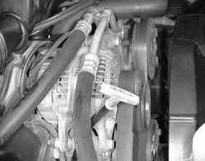

Fig. Dipstick handles are marked for application

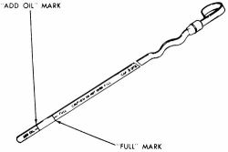

Fig. Engine oil dipsticks are marked with both ADD and FULL marks
- Wipe the dipstick with a clean, lint-free rag and reinsert it. Be sure to insert it all the way.
- Pull out the dipstick and note the oil level. It should be between theSAFE/FULL (MAX) mark and the ADD (MIN) mark.
- If the level is below the lower mark, insert the dipstick and add fresh oil to bring the level within the proper range. Do NOT overfill.

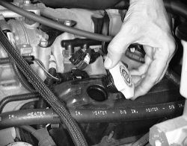
Fig. On some models, remove the oil filler cap from the rocker arm cover to add oil
- Recheck the oil level and close the hood.

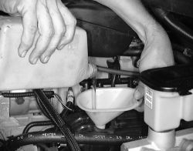

Fig. Even with "easy pour" bottles, it is still wise to use a funnel to keep oil from spilling

Oil Recommendations
Fig. Look for the API oil identification label

